**Energetic Profile-Based Protein Comparison: A Novel Approach for Structural Dissimilarity and Evolutionary Insights**

**Abstract**

The assessment of protein similarity, functional prediction, and the delineation of evolutionary connections stand as pivotal pursuits in the realm of bioinformatics. Protein energy, an indicator of stability, has seldom been utilized for comparing the similarity of two proteins. This study delves into the exploration of protein energy profiles as a novel avenue for comparison, diverging from conventional methods reliant on structural alignment or atomic distances. In this investigation, a distinctive energy profile is assigned to each protein, and their comparative analysis is executed to scrutinize structural characteristics and evolutionary relationships. A key observation is that the energy profile, estimated from sequences, exhibits a robust correlation with energy obtained from structure. The SCOP database is utilized to assess energy profiles at various hierarchical levels, including class, fold, superfamily, and family. Results indicate that energy profiles can encapsulate substantial information about protein structure, revealing notable similarities within specific classes or superfamily or folds. Furthermore, the study illustrates the discriminative potential of energy profiles in distinguishing proteins across diverse species. This is exemplified by the selection of spike glycoproteins from three coronavirus species and the categorization of bacteriocins proteins as small peptides produced by bacteria according to BAGEL annotation. In conclusion, we illustrate the utility of this approach in predicting drug combinations predicated on the distinctiveness of target proteins. The energy computations in this study are performed using knowledge-based functions.

**Keywords**

Energy-based annotation, Structural dissimilarity, Evolutionary relationships, Profile of energy, Knowledge-based potential.

**Introduction**

A thorough understanding of protein function holds paramount importance within the domains of biology, medicine, and pharmacy. While experimental methods exhibit high accuracy in protein function associations, their inherent drawbacks, such as being time-intensive and expensive, have instigated the exploration of computational avenues. The evaluation of protein similarity by comparing two proteins has consistently emerged as a key methodology. This assessment plays a pivotal role in uncovering insights into the functions and evolutionary relationships of proteins. Advances in high-throughput technologies have led to the establishment of extensive repositories containing protein sequences, a substantial proportion of which lack annotations [1]. Conventional computational methods for predicting protein functions predominantly rely on sequence similarity search tools like BLAST [2] and FASTA [3], as well as motif searches [4], contemporary approaches have explored an extensive array of methodologies, including sequence-based techniques [5], omics-data integration [6], phylogenetic profiling [7] and three-dimensional protein structures [8]. All these approaches strive to augment the precision and depth of our understanding of protein functionality. Despite the diversity in methodologies, the underlying commonality revolves around determining protein similarity either through sequence alignment or structural comparison.

Protein stability is a fundamental feature affecting function, activity, and regulation of biomolecules. The energy of a protein structure plays a key role in determining its stability. Knowledge-based potentials, categorized as statistical energy functions, derived from databases of known protein structures that empirically capture the most probable state of a protein and describe microstates of interactions within protein structure [9, 10]. Various types of potential functions leverage information extracted from known protein structures to estimate energies of pairwise interactions. These include distance-dependent [11], dihedral angles, and accessible surface energies [12]. In this study, the Sippl potential function [9] was used to extract distance-dependent knowledge-based potential function. The conventional assumption states that a native protein structure is confined to a state with the minimum total energy, and the more similar a structure is to the native state, the closer the total energy. However, we take a step beyond this assumption by assigning an energy profile to each protein, suggesting the hypothesis that two similar proteins possess analogous energy profiles. To achieve this, a feature vector is assigned to each protein, with each entry representing the summation of energies for a specific pair of amino acids. With 20 amino acids in proteins, this results in 210 pairwise interaction types. Consequently, an energetic feature vector is assigned to each protein for the first time in this study. This 210-dimensional vector represents the intricate energy landscape inherent in the protein structure. We refer to this vector of energies as the "energetic profile," serving as the cornerstone of our analytical approach and providing a robust foundation for further investigative pursuits. The Manhattan distance between the energetic profiles of two proteins is considered a measure of dissimilarity between them. Given the prevailing challenge of experimentally ascertaining the three-dimensional structures of proteins, the estimation of energy based on sequence emerges as a crucial consideration. Dostari et al.[13] introduced a method to estimate energy based on amino acid composition. In our study, we adopted this approach to calculate the energy profile based on sequence. To the best of our knowledge despite extensive studies on protein function and evolution, encompassing protein sequence, secondary structure, and three-dimensional structural attributes, the intrinsic energy of protein structures, which fundamentally influences macromolecular and organismal evolution, remains an underexplored dimension within this domain.

The stratification of proteins into distinct folds/superfamily/families, predicated upon evolutionary consanguinity or shared structural and functional attributes, emerges as an indispensable strategy for precise function prediction. Databases such as CATH (Class, Architecture, Topology, Homologous superfamily) [14] and SCOP (Structural Classification Of Proteins) [15] provide a comprehensive framework, categorizing proteins into hierarchical groups based on their structural features. The SCOP database is a hierarchical classification of protein structures that organizes them into increasingly specific levels, ranging from broad classifications at the top, such as folds and classes, to finer details at lower levels, such as superfamilies and families. We utilized the ASTRAL 40 (95) database (version 2.08) from SCOPe, which comprises a set of domains with no greater than 40% (95%) sequence similarity according to BLAST identity and a filter for E-value similarity score [16].

In this study, we initially compute energy profiles for protein domains within Astral 40 and Astral 95, at both sequence and structure levels. Our findings demonstrate a highly significant correlation between the total energy estimated from sequence and structure, as well as a pronounced correlation between the distances among energy profile estimated from sequence and structure. Utilizing UMAP projections, we observe a clear separation of proteins belonging to the all-alpha and all-beta classes, indicating that the energy profile encapsulates structural information. This discernible separation is also evident at the fold, superfamily, and family levels through random selections. To delve deeper, we randomly selected two folds (a.100 and a.104), two superfamilies (a.29.2 and a.29.3), and two families (a.25.1.0 and a.25.1.2) from SCOP database, calculating energy profiles at both sequence and structure levels. The resulting UMAP plot underscores the informative nature of energy profiles in clustering proteins across different folds, superfamilies, and families. Subsequently, the application of 1-NN classification on two families with CATH IDs 1.10.28.10 and 3.10.28.10 reveals that our energy profile surpasses classical methods such as TM-Score[17], RMSD [18], GR-Align[19], and Yau-Hausdroff distance[20] in terms of accuracy and computational efficiency.

In conjunction with the organizational frameworks provided by SCOP, CATH, and PFAM for the protein universe, it is important to note their limitations, as they may present conflicting classifications and lack the ability to elucidate evolutionary relationships between individual superfamilies across extensive evolutionary distances. Lundin et.al.[21] conducted a comprehensive analysis of protein structures within the functionally diverse ferritin-like superfamily. They employed an evolutionary network construction approach to unveil relationships among proteins beyond the "twilight zone," where sequence similarity alone fails to facilitate meaningful evolutionary analysis. Building on this context, our study leverages profiles of energies to reconstruct a phylogenetic network. Our findings strongly suggest that a substantial and valuable evolutionary signal is preserved within the profile of energy, serving as a representative indicator of protein structure.

To evaluate our methodology for reconstructing the evolutionary connections among spike proteins within SARS-CoV, MERS-CoV, and SARS-CoV-2 coronaviruses, we utilized the CoV3D database[22]. This database is an extensive repository containing a variety of coronavirus protein structures and their complex interactions with antibodies, receptors, and small molecules. Within this dataset, there are 80 chains from SARS-CoV-2, 31 chains from SARS-CoV, and 32 chains from MERS-CoV. Our thorough examination involved creating a 210-dimensional energy profile at both sequence and structure levels. Through the computation of Manhattan distances between all pairs of energetic profiles, we successfully grouped the spike glycoprotein structures into three distinct clusters, corresponding to SARS-CoV, MERS-CoV, and SARS-CoV-2 viruses. This unsupervised clustering method offers a visually elucidating representation of the structural relationships and evolutionary dynamics within this protein family.

We conducted an analysis on a diverse set of bacterial families known as bacteriocins, utilizing the BAGEL database for examination [23] . Bacteriocins are small peptides produced by bacteria, serving as potent antimicrobial agents that target other microbial species. Detecting and comprehending these peptides is crucial due to their ecological significance, but their varied sequences and structures pose challenges for identification using conventional methods. Our findings demonstrate that the energy profile has the capability to categorize these proteins according to BAGEL annotation. BAGEL classifies bacteriocins based on size and stability into RiPPs (also designated as class I bacteriocins), class II bacteriocins (small heat-stable proteins < 10 kDa), and class III bacteriocins (large heat-labile proteins > 10 kDa).

Finally we evaluated our method in drug combination prediction. The identification and validation of effective drug combinations, essential for treating complex diseases, face challenges due to the combinatorial explosion of potential drug pairs. Cheng et al. introduced a network-based methodology leveraging the human protein-protein interactome to discover clinically effective drug combinations, demonstrating that topological relationships between drug-target modules, as indicated by a separation measure, reflect both biological and pharmacological relationships [24]. In this study, we introduce a separation measure based on the similarity between profiles of energies of protein targets, revealing a strong correlation with the separation measure based on protein-protein interaction network and suggesting the energy profile as a promising predictor for drug combinations, requiring only protein sequences and offering faster computation than network-based approaches.

This study offers a means to characterize and compare proteins using energy profiles, enabling predictions of their structural and functional properties. Furthermore, this computational framework not only facilitates our understanding of individual protein behavior but also contributes to the broader exploration of evolutionary relationships, functional annotations, and drug discovery in the intricate world of proteins.

**2 Materials and Methods**

A non-redundant structural dataset of 6944 protein chains was culled by PISCES from PDB with pairwise sequence identity < 50%, resolution < 1.6 Å, R-factor < 0.25, protein length > 40 and < 1000 residues. These proteins were applied to train and calculate the knowledge-based potential function.

**2.1 Pairwise distance-dependent knowledge-based potential.**

It is generally assumed that two atoms are in contact if their spatial distance is less than a certain threshold. As a result, atoms separated by less than a constant number interact. There is no direct interaction between two atoms when there is a third atom between two close atoms. Based on Delaunay tessellation, a representation that eliminates contact between two atoms when a third atom is between them, a physical contact can be accurately modeled. In 2014, Mirzaie et al. introduced an all-atom knowledge-based potential based on Delaunay Tessellation [11]. In this study we apply this potential function to calculate the potential of pairwise contact. The energy between the two atoms i and j at distance d, is calculated as follows:

$∆E^{ij}\left(d\right)=RT\left[lnln \left(1+M_{ij}σ\right) -ln⁡(1+M_{ij}σ(\frac{f_{ij}(d)}{f_{xx}(d)}))\right]$ (1)

where the temperature *T* was set to 293 K, corresponding to *RT* of 0.582 kcal/mole, where *R* is the gas constant. $M_{ij}$  is the number of observations for atomic pair $i$  and $j$ , $f_{ij}(d)$ is the relative frequency of occurrence for $i$  and $j$  in distance class $d$, $f_{xx}(d)$ is the relative frequency of occurrence for all atomic pairs in distance shell $d$ , and $σ$ is the weight given to each observation. As discussed by Sippl, it was assumed that $σ=0.02$. The potential energy associated with the interaction of residues A and B denoted by $∆E(A,B)$ is estimated by summing the pairwise potentials between the atoms of each of these residues as follows:

$∆E(A,B)=\sum_{i∈A,j∈B}{∆E^{ij}\left(d\right)}$ (2)

which the sum is on all pairs of atoms in contact with the Delaunay triangulation method.

Consider the set T, which encompasses all 20 types of amino acids in proteins. Given that there are 210 unique amino acid-amino acid interaction types among these 20 amino acids, the total count of unique $∆E(A,B)$ values are 210. As a result, we create a 210-dimensional vector to represent distance-dependent energy interactions between residues, with each dimension representing the energy interaction between distinct pairs of amino acids. We call this 210-dimensional vector as the **Structural Profile of Energy (SPE)** of a protein structure.

**2.2 The pairwise energy content estimated from amino acid composition.**

The knowledge-based potential function discussed in the previous section relies on having the three-dimensional structure of a protein. Nevertheless, it's worth noting that the three-dimensional structures of numerous proteins have not yet been determined experimentally. Dosztányi et al. proposed a method to estimate the energy from a protein sequence [13]. They approximated $\frac{E}{L}$, the total energy per amino acid, based on the protein’s amino acid composition. Let $L$ be the length of the sequence, $N_{i}$ be the number of amino acid residues of type $i$ in the sequence and $n_{i}=\frac{N_{i}}{L}$ be its relative frequency. The energy per amino acid, as approximated by Dosztányi et al, is as follows [13]:

$$\frac{E_{estimated}}{L}=\sum_{i,j}^{20}{{n_{i} P}_{ij}{ n}_{j} (3)}$$

where $P$ is the energy predictor matrix estimated using protein structures from the training dataset as detailed by Dosztányi et al [13]. For each pair of amino acid types $i$ and $j$, we used the following equation to estimate the energy $E_{ij}$ based on amino acid sequence composition:

$$E_{ij}=n_{i}\sum_{j}^{20}{{ P}_{ij}{ n}_{j} (4)}$$

As a result, we create a 210-dimensional vector to represent energy between amino acid types using amino acid composition. We call this 210-dimensional vector as the **Compositional Profile of Energy (CPE)** of a protein sequence.

**3 Results**

**Correlation between Energy estimated based on structure and Sequence**

Initially, we calculated energies for protein domains in the ASTRAL40 and ASTRAL95 datasets using both structure- and sequence-based methods. The ASTRAL 40 (95) dataset consists of protein domains with sequence similarities of less than 40% (95%) [25]. This dataset offers a comprehensive description of structural and evolutionary relationships among proteins from the Protein Data Bank. As mentioned in Method section, we can calculate the total energy and the profiles of energy form protein structure or predicted from sequences. Figure 1A illustrates the correlation between the total energy estimated from structure on y-axis and from sequence on x-axis. The observed high correlation coefficient suggests that sequence-based energy estimation serves as a reliable approximation, particularly in scenarios where the protein structure is unidentified. Similarly, Figure 1B depicts the connection between energy profile distances for all pairs of domains in the ASTRAL40 and ASTRAL95 datasets, as estimated from both structure and sequence. Likewise, a strong correlation exists between the distance of pairs of energy profiles estimated from sequence and structure.

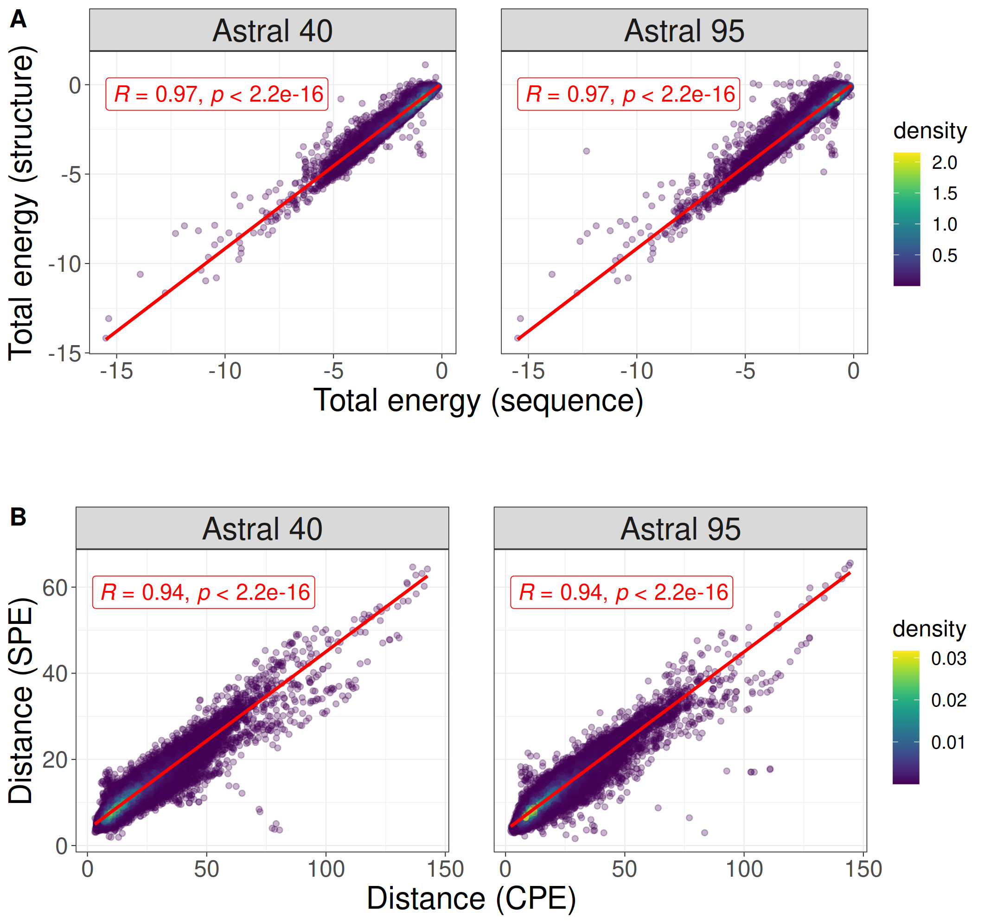

Figure 1. The correlation between total energy estimates derived from protein structure and sequence for protein domains within Astral 40 and Astral 95 data bases (depicted in A). Additionally, the figure presents the correlation between the distance of energy profile pairs for domains in Astral 40 and Astral 95 (shown in B).

The stability, mutational robustness, and design adaptability of α-helices relative to β-strands in natural proteins have been widely acknowledged in scientific literature[26]. To investigate this phenomenon, Figure 2 presents the distribution of total energy within protein domains from the ASTRAL40 and ASTRAL95 datasets, categorized into four structural scope classes: all-alpha, all-beta, alpha+beta, and alpha/beta. Total energies, normalized by protein length, are analyzed to discern patterns across these structural classes. The figure highlights significant differences in total energy among domains with different structural compositions, suggesting diverse energetic landscapes associated with distinct protein structures. This observation is consistent with similar trends observed in energy estimations derived from sequence information, reinforcing the importance of structural motifs in influencing the energetic properties of proteins.

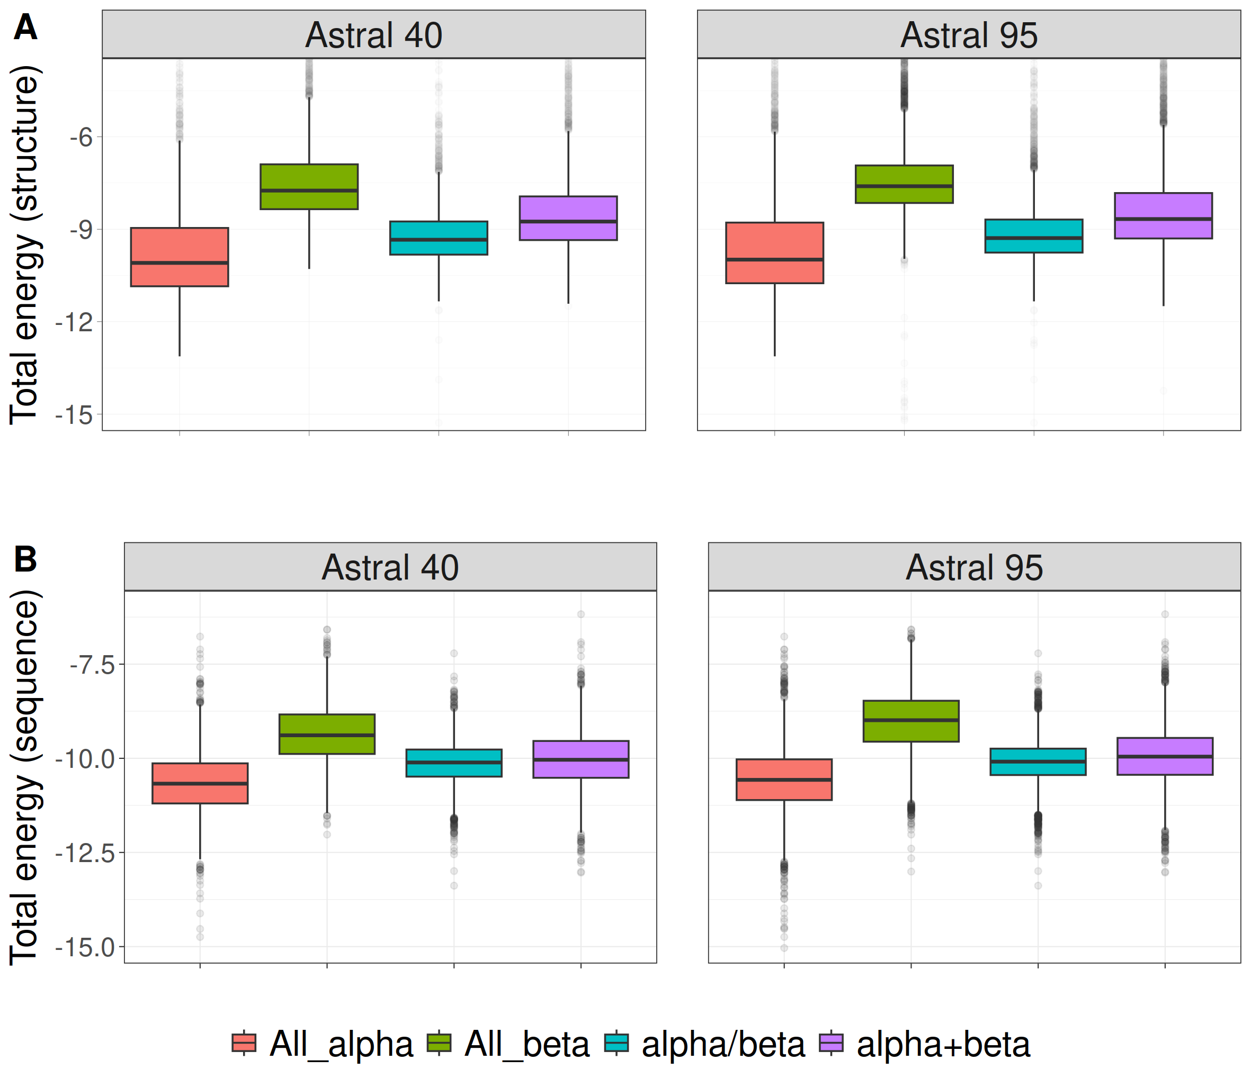

Figure 2. The distribution of normalized total energy in protein domains from ASTRAL40 and ASTRAL95 datasets based on protein structure (A) and sequence (B) across various structural scope classes. In the ASTRAL40 dataset, there are 2644, 3059, 4463, and 3653 protein domains in the all-alpha, all-beta, alpha+beta, and alpha/beta classes, respectively. Similarly, in the ASTRAL95 dataset, there are 3443, 10164, 9344, and 7474 protein domains in the all-alpha, all-beta, alpha+beta, and alpha/beta classes, respectively.

We visualized the energy profiles generated by sequence and structure for domains belonging to the all-alpha and all-beta classes. As depicted in Figure 3, the UMAP embeddings of energetic profiles effectively capture the structural characteristics that differentiate between all-alpha and all-beta domains. This visualization highlights the presence of distinct energy profiles between all-alpha and all-beta domains, a consistency that is also evident in sequence-based energy profiles.

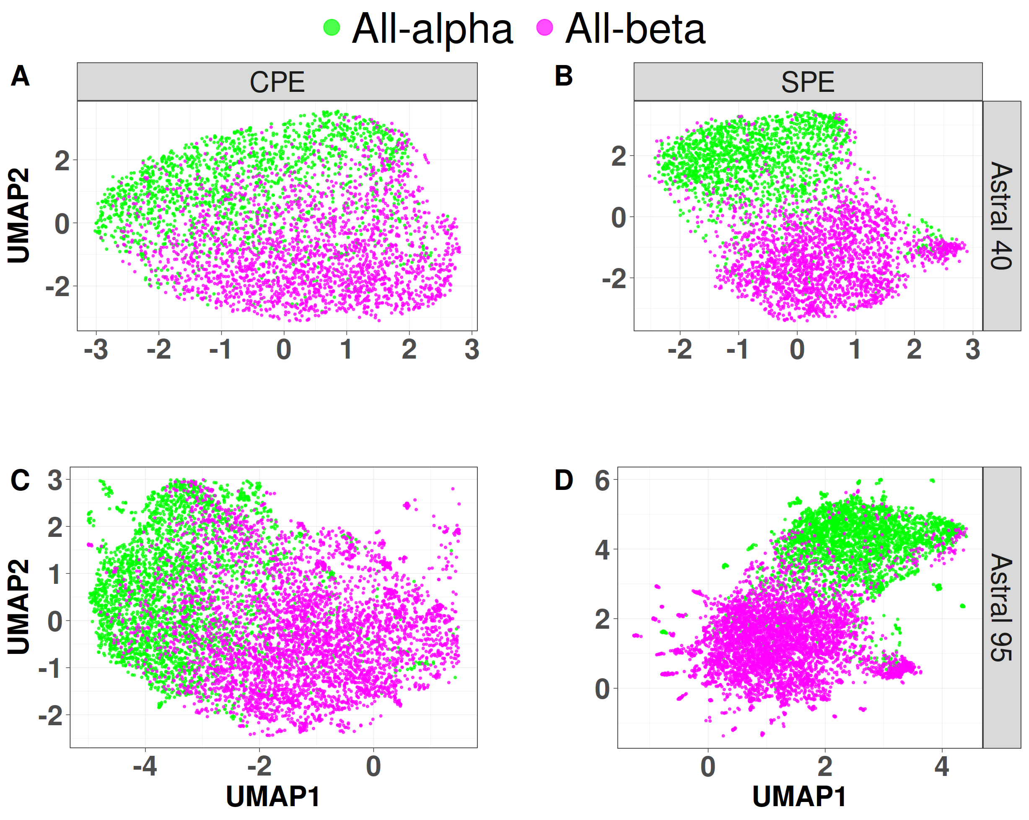

Figure 3: UMAP projection of SPE and CPE shows the separation of the all-alpha (green point) and all-beta (pink point) proteins selected from the ASTRAL 40 and 95 dataset. A) SPE of ASTRAL40, B) CPE of ASTRAL 40, C) SPE of ASTRAL 95, and D) CPE of ASTRAL 95. Dots represent two dimensional UMAP projection of SPE for individual sequences. UMAP plots were generated by parameters n_neighbors = 20 and min_dist = 0.1.

To explore the structural information of energy profiles at lower hierarchical levels of SCOP, we randomly selected two folds (a.100 and a.104) from the all-alpha class, two superfamilies (a.29.2 and a.29.3) from the fold a.29, and two families (a.25.1.0 and a.25.1.2) from the superfamily a.25.1. In Figure 4, each panel showcases two figures, with the left figure generated by CEP profiles and the right figure by SEP profiles. The UMAP plot in Figure 4 underscores that protein domains within the same fold, superfamily, or family share similar energy profile patterns.

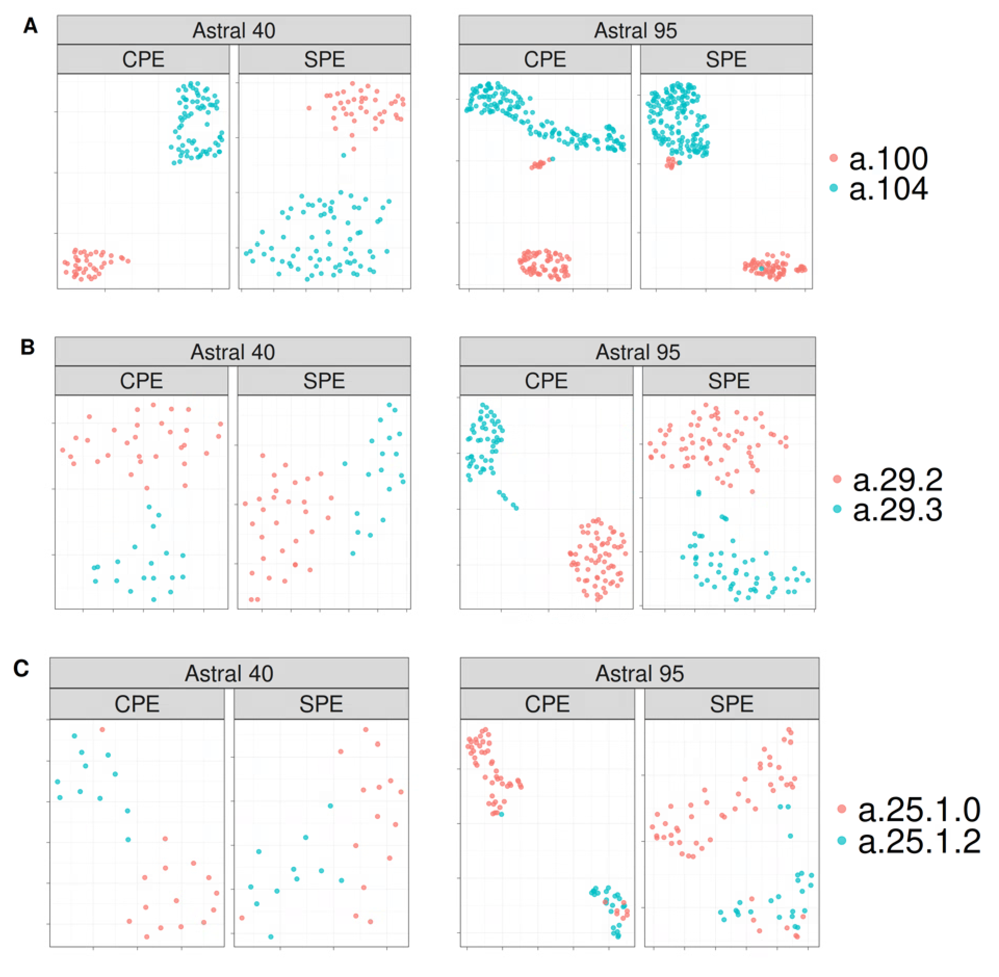

Figure 4. The UMAP projection of Structural Energy Profiles (SEP) and Compositional Energy Profiles (CEP) on protein domains from Astral40 and Astral 95 represents the structural information embedded in energy profiles across hierarchical levels of SCOP; each panel includes two figures, one generated by CEP (left panel) and the other by SEP (right panel), revealing that protein domains sharing the same fold, superfamily, or family exhibit comparable energy profile patterns. The folds a.100 and a.104, superfamilies a.29.2 and a.29.3, as well as families a.25.1.0 and a.25.1.2, are randomly selected for analysis, and the UMAP plots are generated using parameters n_neighbors = 20 and min_dist = 0.1.

To delve deeper into the differences in distances among protein domains within the same class, we calculated pairwise distances between the energy profiles of protein domains within the all-alpha class from the Astral 95 dataset. Subsequently, we compared these distances with the distances of energy profiles from protein domains across different classes. In Figure 5, each panel displays two figures, with the left figure generated by SEP profiles and the right figure by CEP profiles. As depicted in Figure 5A, interclass distances are notably lower than intraclass distances. Similar results were obtained when we calculated pairwise distances from protein domains within fold a.29 and compared them with pairwise distances from protein domains in different folds within the all-alpha class (Figure 5B). Likewise, the distances between energy profile patterns of protein domains within the same superfamily a.29.3 are significantly less than the distances between energy profiles of protein domains within fold a.29 that belong to different superfamilies (Figure 5C). Consequently, it can be inferred that energy profiles of domains belonging to the same superfamily/fold/class exhibit greater similarity than those from different superfamilies/folds/classes.

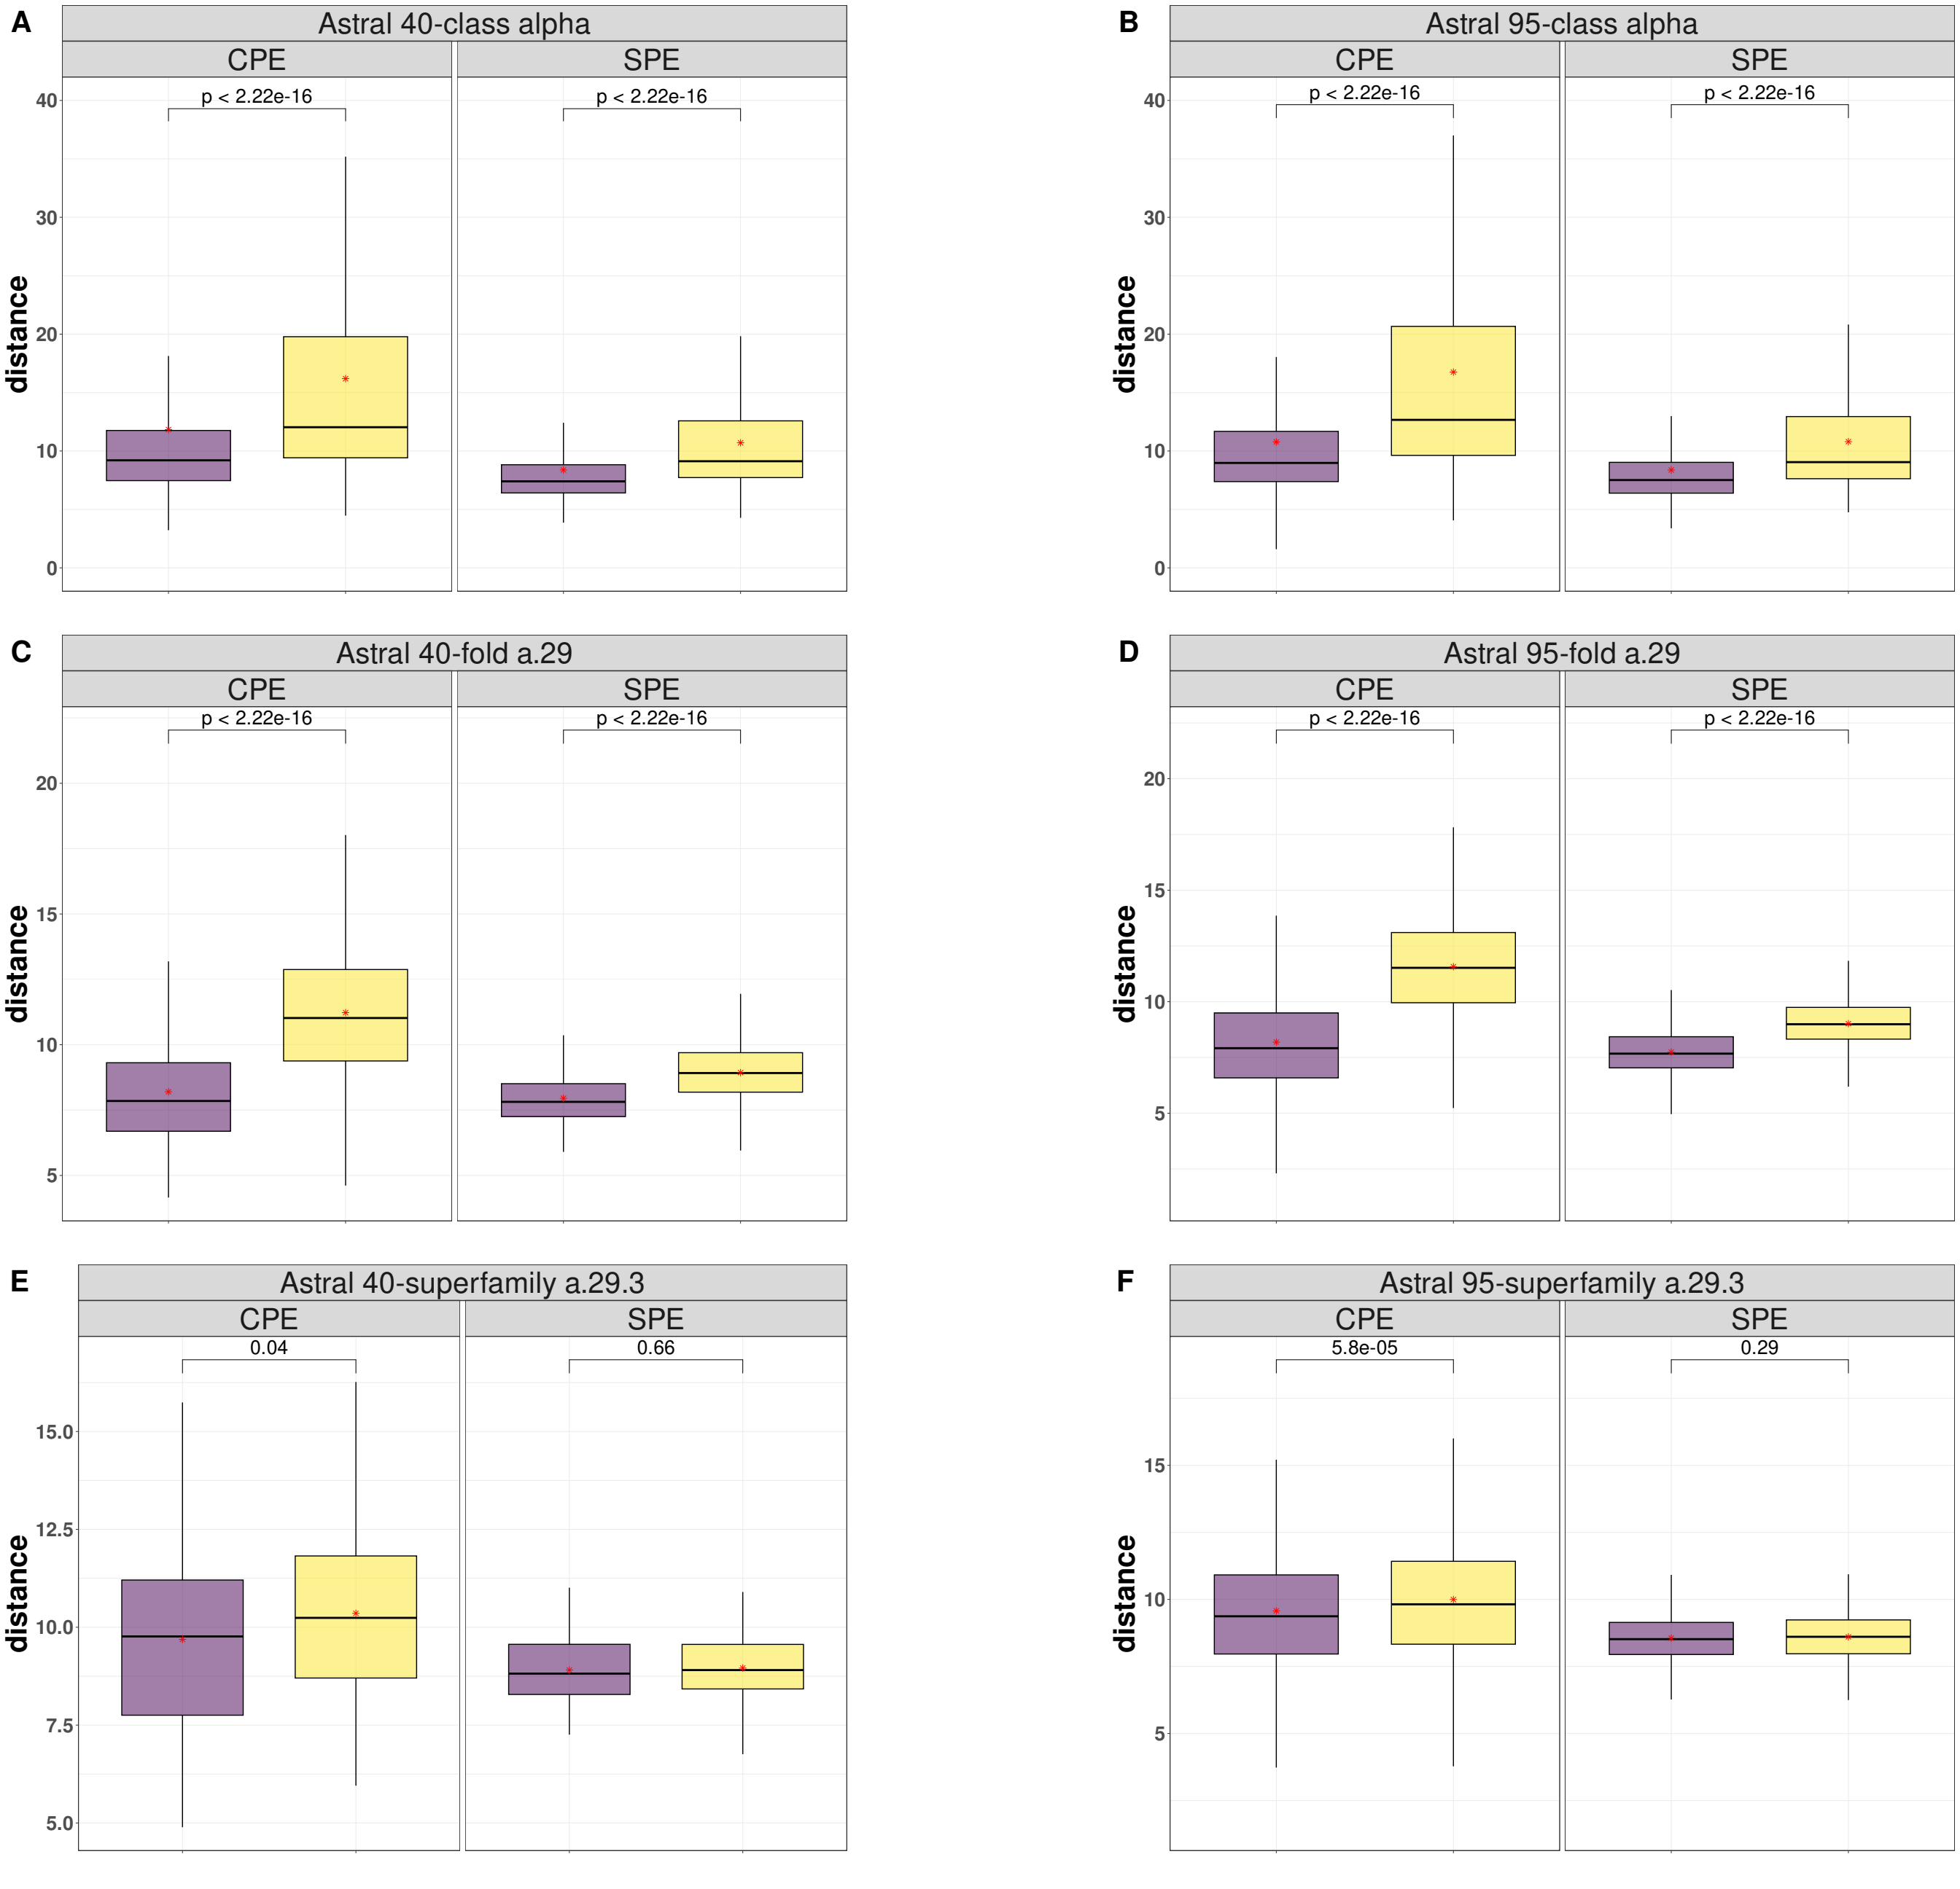

Figure 5: Comparative Boxplots of Pairwise Distances among Energy Profiles in Astral 40 and Astral 95, depicting A) intraclass distances within the all-alpha class (in purple) versus interclass distances (in yellow), B) intraclass distances within the a.29 fold (in purple) versus distances from protein domains in different folds within the all-alpha class (in yellow), and C) intraclass distances within the a.29.3 superfamily (in purple) versus distances from protein domains in different superfamilies within the fold a.29 (in yellow). Each panel presents two figures, one generated using Compositional Energy Profiles (CEP, left panel) and the other using Structural Energy Profiles SEP, right panel).

To assess the profile of energy in protein superfamily classification, we investigated five distinct SCOP superfamilies: winged helix (a.4.5), PH domain-like (b.55.1), NTF-like (d.17.4), Ubiquitin-like (d.15.1), and Macroglobulin (b.1.29)[27]. Our classification strategy incorporated energetic profiles as features, employing 1NN and Random Forest (RF) classifiers as our models. To ensure the robustness and generalization of our models, we subjected RF to rigorous 10-fold cross-validation. The outcomes, presented in Table 1, encompass both accuracy and F1-measure, revealing the performance of our models. As indicated in the table the performance of both classifiers are close to 100%.

*Table 1: Total accuracy and F1 measure for each of the five superfamilies by 1-NN and the results of 10-Fold cross validation with random forest.*

|  |  |  |  |  |  |  |
| --- | --- | --- | --- | --- | --- | --- |
| Method | Accuracy | F1 Measure | | | | |
| wigend_helix | PH.domain-like | NTF-like | Ubiquitin-like | Immunoglobulins |
| 1NN | 0.98 | 0.98 | 0.96 | 0.99 | 0.99 | 0.99 |
| RF | 0.99 | 0.97 | 0.97 | 0.99 | 0.99 | 0.99 |

It is commonly assumed that proteins sharing similar structures also exhibit similar functions. Various measurements, such as RMSD, TM-score[28], RG-align[19], and Yau-Hausdorff distance[20], have been developed to assess protein structure similarity. Here, we employed a benchmark dataset sourced from the CATH v4.2.0 database, comprising 260 protein domains from two distinct protein families: the C-terminal domain in the DNA helicase RuvA subunit (representing the Alpha class, characterized by Orthogonal Bundle Architecture, Helicase, and Ruva Protein fold, with CATH Code: 1.10.8.10), and the Homing endonucleases (belonging to the Alpha and Beta class, featuring Roll Architecture, and Endonuclease I-creI fold, with CATH Code: 3.10.28.10). The protein domains varied in the number of residues, ranging from 44 to 854, with an average of 211.

We employed the 1-nearest neighbor (1-NN) classification method to categorize proteins based on GR-Align, RMSD, TM-score, Yau-Hausdorff distance, and the distance between profiles of energy as a measure of protein dissimilarity. As outlined in Table 1, our approach exhibited superior accuracy and faster processing times compared to other methods. It is noteworthy that our method obviates the need for superimposing two protein structures or conducting structural alignments; instead, we calculate the profiles of energies and determine the distance between these profiles. The computations were executed on a PC with a configuration of 2.40 GHz and 8 GB RAM. Table 2 provides a detailed breakdown of results and processing times, highlighting the efficient implementation of energy profile calculation and the 1-NN algorithm, accomplished in approximately 10 minutes on a system with a 2.4 GHz processor and 4GB RAM. Impressively, our methodology achieved a remarkable classification accuracy of 97% in distinguishing between the two protein families.

*Table 2: The accuracy and computation time for 1-NN classifier based on GR-Align, RMSD, TM-score, Yau-Hausdorff distance, and the distance between profiles of energy (CEP) as a measure of protein dissimilarity.*

|  |  |  |  |  |  |  |
| --- | --- | --- | --- | --- | --- | --- |
| Method | GR-Align | RMSD | TM-Score | YH (10Rotation) | YH (2500Rotation) | CEP |
| Accuracy | 62.3% | 59.2% | 61.5% | 70.8% | 81.5% | 97% |
| Time | 2 min | 1 h | 9h 20 min | 10 min | 4h 10 min | 3 min |

**3.6 Phylogeny Inference Using Energy Profiles**

In the realm of structural biology and evolutionary analysis, three-dimensional protein structure classification and the alignment of multiple sequences stand as formidable tools for uncovering structural similarities and deducing phylogenetic relationships. A phylogeny, often visualized as a tree, serves as a narrative of evolutionary processes, elucidating the intricate relationships that exist among various entities, be they genes, populations, species, or other biological units.

In this section, we leverage energy profiles for the inference and reconstruction of phylogenetic trees. Specifically, we apply this method to unveil the phylogenetic relationships within two distinct biological contexts: the coronavirus spike glycoprotein structures and the ferritin superfamily. Through this analysis, we aim to shed light on the evolutionary histories and interconnections that underlie these essential biological entities, ultimately enriching our understanding of their structural evolution and functional relationships.

**3.6.1 Exploring the Phylogeny of the SARS-CoV-2 proteins**

Over the past two decades, Coronaviruses (CoVs) have been associated with various outbreaks, including the 2002–2003 SARS-CoV outbreak, the 2012 MERS-CoV incident, and the recent COVID-19 pandemic initiated by SARS-CoV-2 in late 2019. Since February 2020, a considerable number of SARS-CoV-2 protein structures have been recorded in the Protein Data Bank (PDB). One pivotal viral protein, the spike glycoprotein, has garnered significant attention. As a transmembrane glycoprotein, it plays a central role in viral infection by facilitating host receptor binding and stands as the primary target for neutralizing antibodies and vaccine design. To thoroughly investigate the structural landscape of these spike glycoproteins and gain insights into their evolutionary connections, we utilized the CoV3D database (https://cov3d.ibbr.umd.edu), a comprehensive repository containing diverse coronavirus protein structures and their complex interactions with antibodies, receptors, and small molecules[22].

From the CoV3D database, we curated a dataset comprising 143 spike glycoprotein structures distinguished by the presence of the closed receptor binding domain (RBD) within their structure. This dataset encompasses 80 chains from SARS-CoV-2, 31 chains from SARS-CoV, and 32 chains from MERS-CoV. To scrutinize the structural variations and relationships among these spike glycoproteins, we generated a 210-dimensional profile of energies at both sequence and structure levels. By calculating Manhattan distances between all pairs of energetic profiles, we successfully categorized the spike glycoprotein structures into three distinct clusters through unsupervised clustering based on these distances. These clusters correspond to the SARS-CoV, MERS-CoV, and SARS-CoV-2 viruses, offering a visually informative representation of the structural relationships within this protein family ( Figure 6).

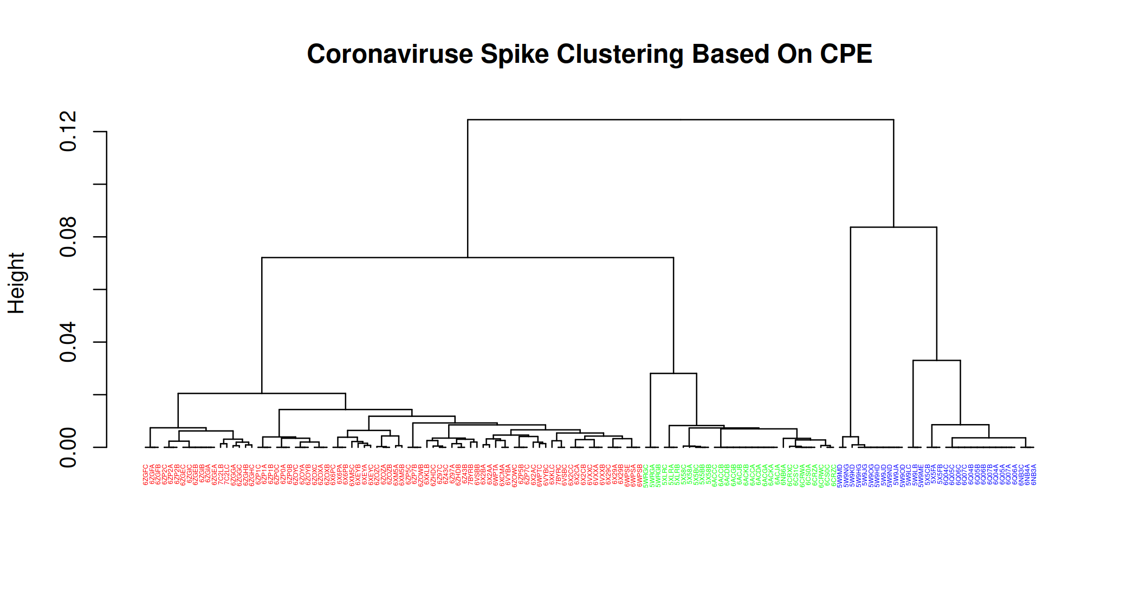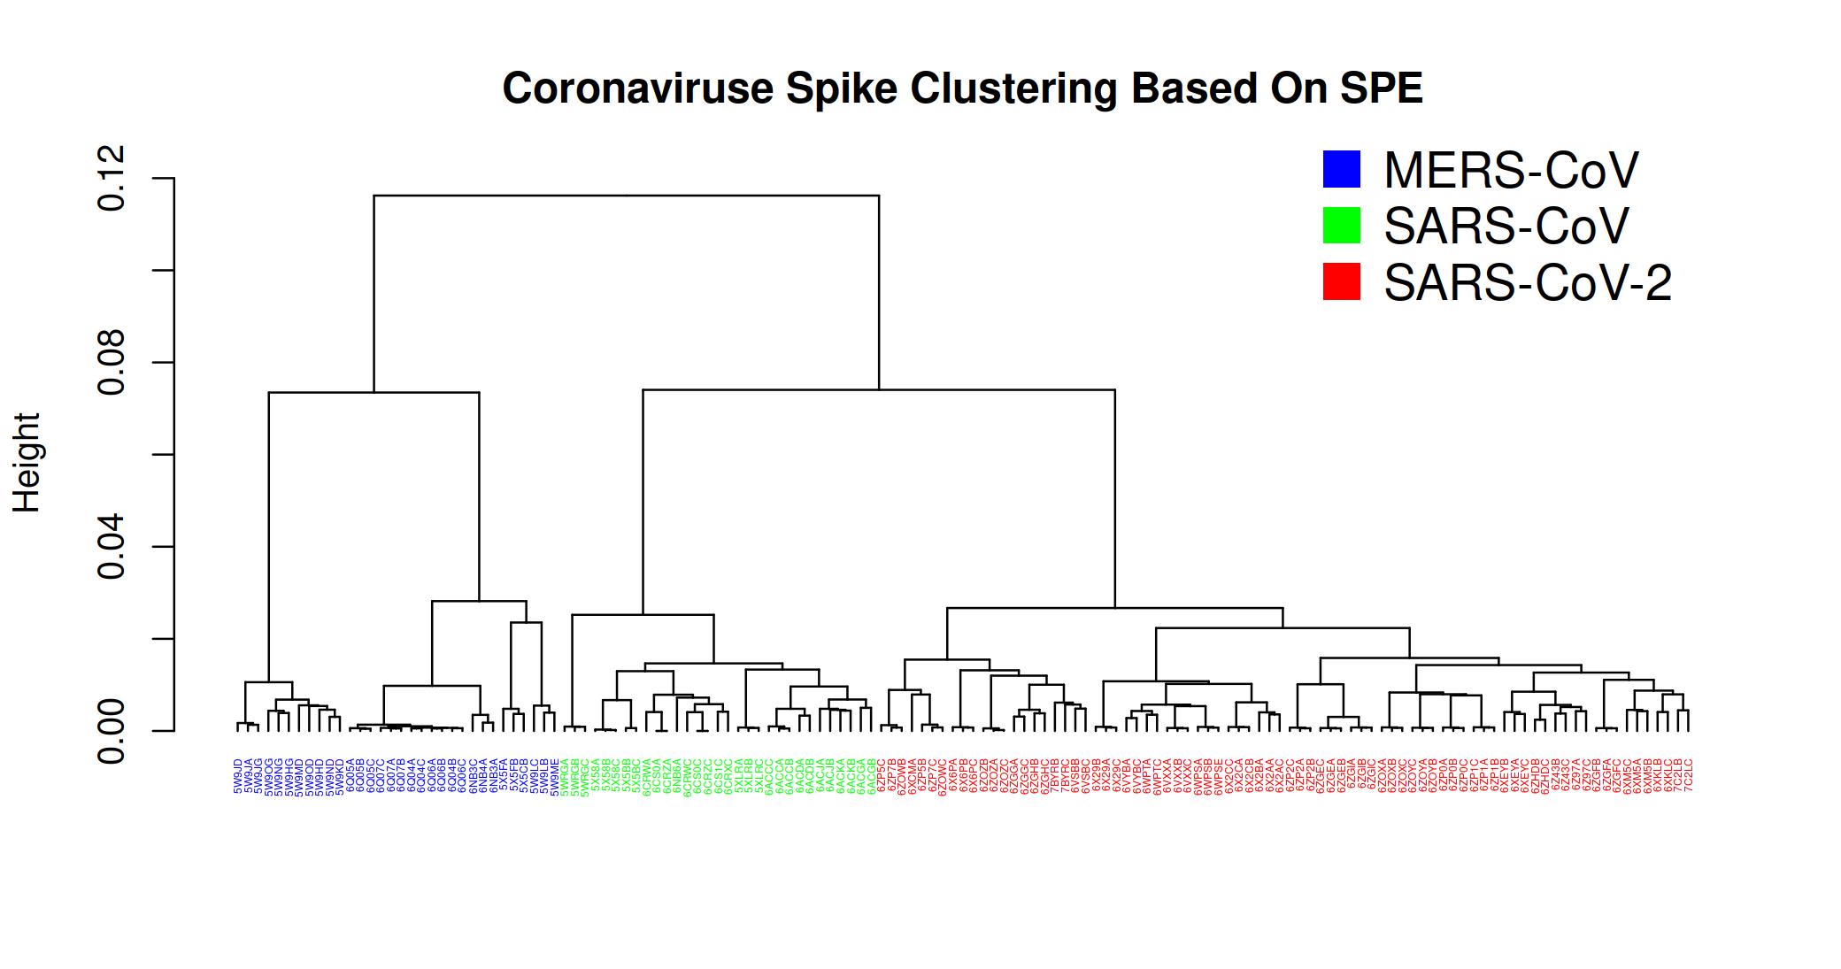

Figure 6: The dendrograms illustrate the clustering of spike glycoprotein structures from three viruses SARS-CoV, SARS-CoV-2, and MERS-CoV. The clustering is based on pairwise distances of energy profiles derived from A) protein structure and B) protein sequence. Each leaf on the dendrogram is labeled with the PDB-IDs of the corresponding chains, and the leaves are color-coded to represent the virus of the spike glycoprotein structure).

**3.6.2 Exploring the Phylogeny of the Ferritin-Like Superfamily**

Several significant databases aim to organize the protein universe at a high level, such as Pfam relying on sequence information, and both SCOP and CATH utilizing protein structural data. These databases categorize proteins into families or superfamilies based on measures of either sequence or structural similarity. While these databases are essential for outlining broad structural relationship, they often present conflicting classifications, and lacking information on evolutionary relationships among individual superfamily components[21]. SCOP superfamilies contain protein families that are assumed to be evolutionary related based on sequence and structural similarity and functional commonalities. Lundin et.al [21] investigated how ferritin-like proteins are classified across Pfam, SCOP, and CATH. Notably, this superfamily encompasses a diverse range of proteins, including iron-storing ferritins, methane monooxygenases, the small subunit of RNR R2, rubrerythrins, bacterioferritins, Dps (DNA binding protein from starved cells that protects against oxidative DNA damage), and Dps-like proteins. As discussed by Lundin et.al at the superfamily level, the classification of the “ferritine-like” superfamily appears consistent across these databases but does differ in the amount of information provided regarding the relationships and functions of superfamily constituents. So although the classification in all three databases is hierarchical, they do not encompass all level of functional and evolutionary information. The low sequence similarities across this superfamily make it feasible to construct sequence-based phylogenies only for specific subsets. Consequently, addressing this challenge requires efforts to integrate structural information with sequence-based phylogenies. Lundin et al. [21] and Malik et al. [29] delved into the evolutionary relationships of this superfamily by creating a phylogenetic network. They employed the distance-based NeighborNet network method, utilizing distances calculated through structure-based alignment methods. To reconstruct the previously published structural phylogeny of the ferritin-like superfamily, we utilized the same protein structures within this superfamily as Lundin et al. and Malik et al. The dataset specifically focuses on the SCOP superfamily, Ferritin-like (a.25.1) encompassing two manually curated protein families: Ferritin (a.25.1.1) and RiboNucleotide Reductase-like [RNR] (a.25.1.2). The “Ferritin” family contains ferritins, bacterioferritins, and Dodecameric ferritin homolog (Dps) proteins and the “RiboNucleotide Reductase-like” family contains the activating subunit of class I ribonucleotide reductase (RNR R2), BMM, and Fads. Following this, we computed the Structure Profile Energetics (SPE) for each protein and determined the distances between SPEs. The reconstruction of the phylogenetic tree was achieved using the neighbor-joining method and showed in Figure 7[30].

Our results suggest that the energetic phylogenies within the ferritin-like superfamily unveil significant relationships among its members, aligning with known evolutionary connections and functional roles. In line with prior investigations, a key observation is that the resulting phylogenetic tree exhibits two primary branches, corresponding to two families a.25.1.1 and a.25.1.2. Consequently, our methodology accurately bifurcates this superfamily into two families. Additionally, our approach faithfully replicates the grouping presented in the figure by Lundin et al. in 2012 [21]. Delving into specifics, the family a.25.1.1 further divides into four subgroups: "ferritins," "Dps and related," "Rubrerythrin," and "Bacterioferritins." On the other hand, the second branch related to the a.25.1.2 family, despite SCOP and CATH assigning these proteins to a unified RNR-like family, reveals three distinct families according to Pfam—Phenol_Hydrox (PF02332), Ribonuc_red_sm (PF00268), and Fatty acid desaturase (PF03405). Our results consistently support this more detailed sequence-based classification, as well as the further subdivision of the BMMs into BMMa and BMMb.

There are some proteins in our networks fall outside of the major groupings in our networks, all of which are classified as Ferritins by CATH, with most also classified as ferritins by SCOP. For instance, in our network, 1otkA is closer to the RNRs rather than the ferritins. It is noteworthy that Pfam classifies this protein into PaaA_PaaC, with 1otkA the only member of PaaA_PaaC. Another protein is 3ee4A which Pfam classifies as Ribonuc_red_sm, possibly because of its sequence similarity to RNR R2 proteins [31]. In our network this structure clearly occupies an outgroup position relative to the RNR R2 structures. This is functionally consistent with its ligand-binding pocket, which indicates that it is a substrate oxidizing enzyme, and its lack of competence as an RNR R2 [31, 32].

In the Fatty-acid group, there is a distinct cluster of plant Fads (2uw1A-B, 1afrA), whereas the Mycobacterium tuberculosis protein (1za0A) appears more distantly related. As discussed by Lundin et al. [21] unfortunately, this is the only solved structure of a bacterial Fad. It is also one of a paralogous pair and not the one considered functional. The structure of the functional Fad has not yet been possible to solve [33]. With such a skewed data set, it is difficult to judge how well our energetic-based network identifies evolutionary relationships within the Fad group.

Proteins 1mtyB-D, 2incB, 2inpC, and 3dhgA are members of the PF02332 family. This protein family includes several components of multicomponent enzyme systems predominantly found in Proteobacteria and Actinobacteria, including subunits alpha and beta of a methane monooxygenase and an alkene monooxygenase system, small and large subunits of propane 2-monooxygenase system and P1 protein of phenol hydroxylase. Through sequence-based phylogenies [34, 35], it has been proposed that bacterial multicomponent monooxygenases (BMMs) evolved through duplication and divergence, resulting in distinct catalytic (α) and non-metal binding (β) subunits. While BMMs generally exhibit low substrate specificity, the discrimination between α and β subunits into two clans—one with proteins annotated as metal iron-bindings (1mhyD B, 3dhgA) and another subgroup comprising non-metal bindings (2inpC, 2incB)—is evident. This suggests that our energetic analysis can uncover both recent and more distant evolutionary relationships.

Concerning the 2fzfA protein, SCOP and CATH classify it as Ferritin, and Pfam categorizes it within the Rubrerythin group. In the study by Lundin et al[21]., this protein is not placed in the Ferritin group, but in our study, it is classified as belonging to Ferritins. It's worth noting that RCSB classifies it as UNKNOWN FUNCTION.

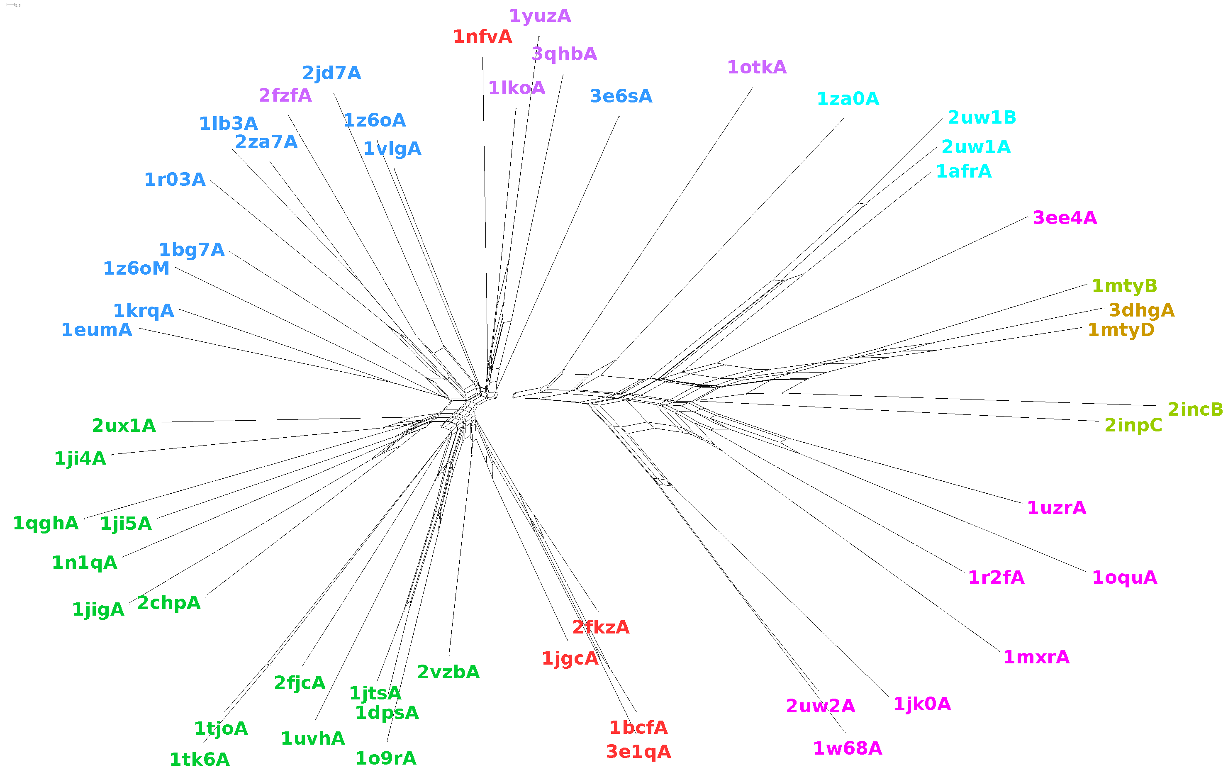

**A**

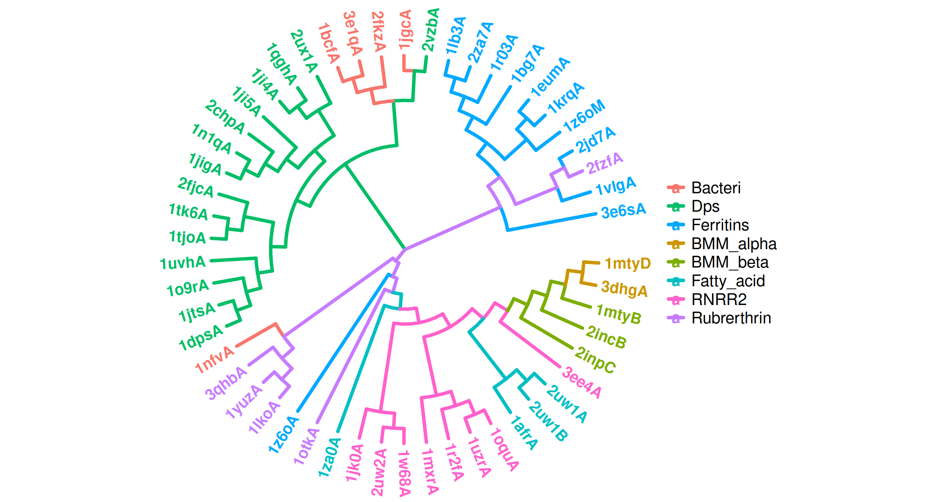

**B**

Figure 7: Energy-based phylogenetic network of the ferritin-like superfamily. The two large SCOP families, ferritins (a.25.1.1; Bacteri, Ferritins, Dps and Rubrerythrin) and ribonucleotide reductase-like (a.25.1.2; BMM_alpha, BMM_beta, Fatty_acid and RNRR2) separated in the tree with smaller groups. A) Network-based phylogeny, B) Neighbor joining phylogeny.

In this section, we analysed a diverse set of bacterial families called bacteriocins, utilizing the BAGEL database for analysis[23]. Bacteriocins are small peptides produced by bacteria, functioning as potent antimicrobial agents that target other microbial species. Detecting and understanding these peptides is crucial due to their ecological importance, but their diverse sequences and structures make them challenging to identify using traditional methods. To address this issue, the BAGEL tool was developed in 2006, specifically designed for identifying Ribosomally synthesized and post-translationally modified peptides (RiPP) and bacteriocin biosynthetic gene clusters (BGCs). BAGEL categorizes bacteriocins based on size and stability into RiPPs (also defined as class I bacteriocins by BAGEL), class II bacteriocins (small heat stable proteins < 10 kDa) and class III bacteriocins (large heat-labile proteins > 10 kDa). As shown in Figure 8, our analysis revealed that profile of energy (CEP) can clearly partition bacteriocins according to BAGEL annotation.

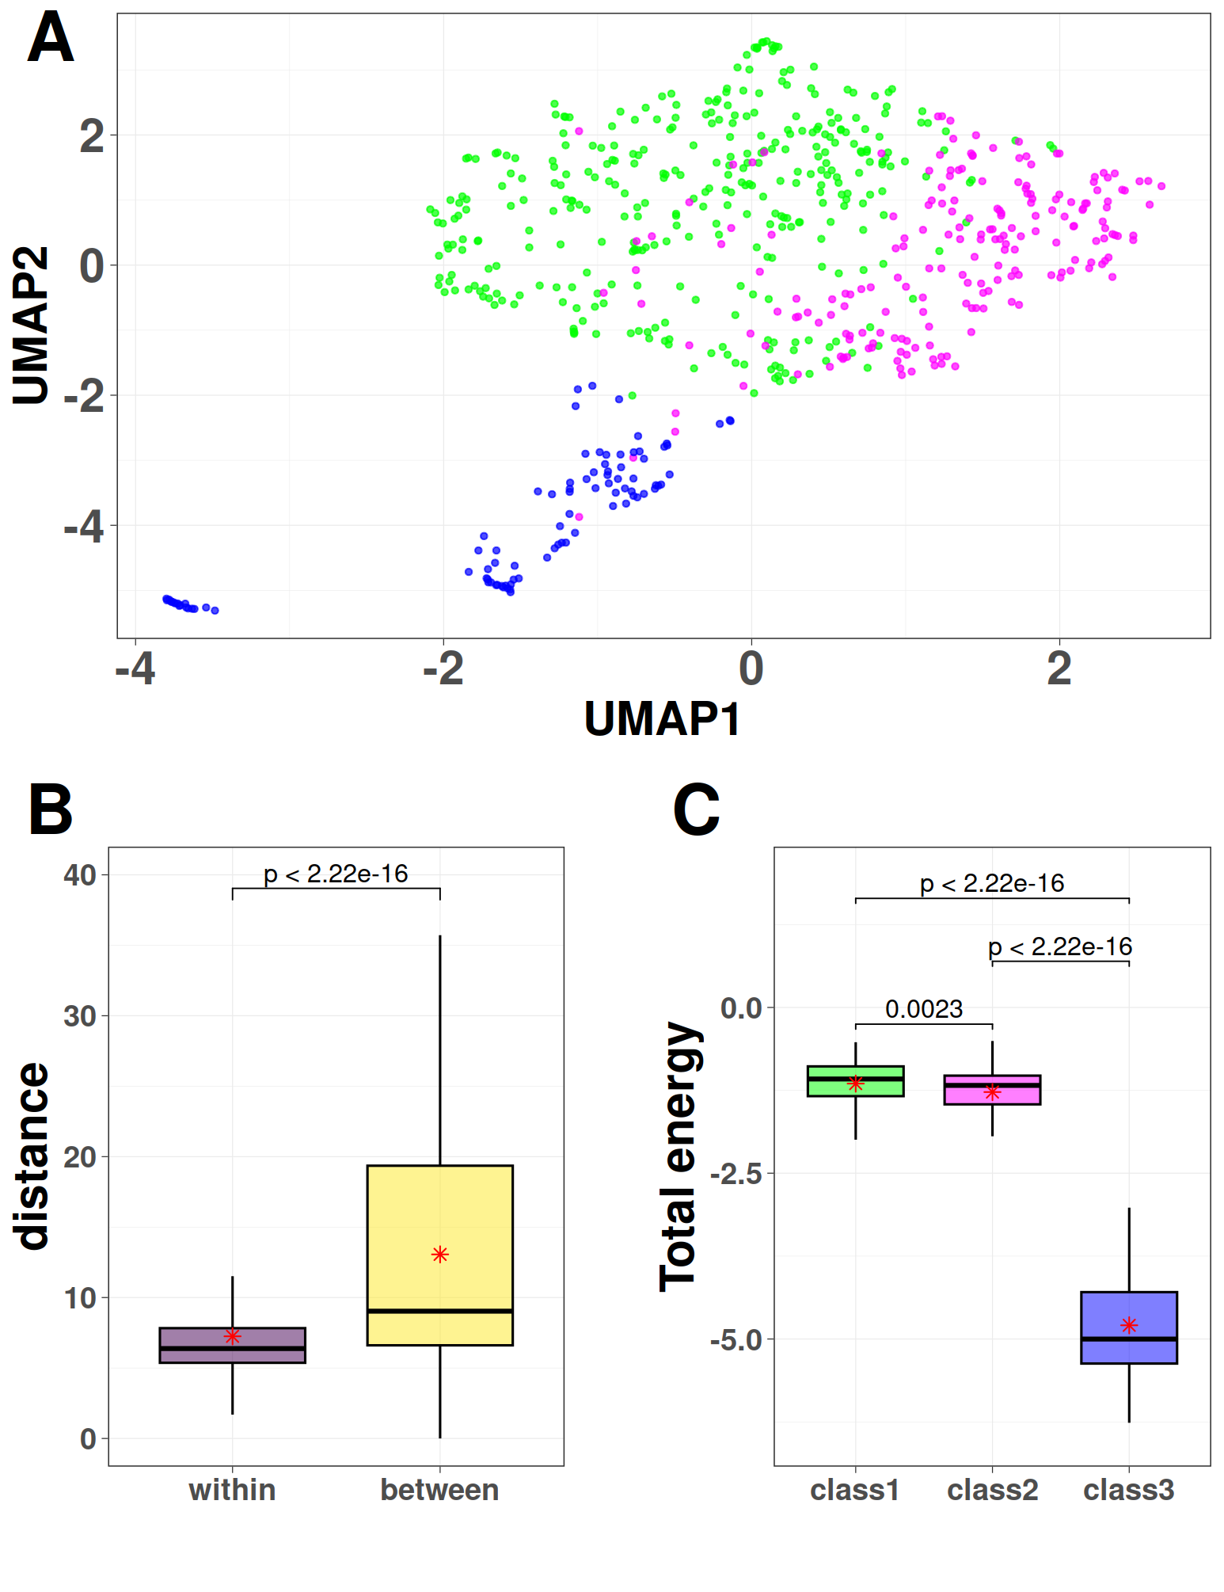

Figure 8. Visualization of profile of energies embeddings using UMAP for 689 proteins across three classes of bacteriocins. A) The boxplots of distances between profile of energies of proteins at the same class versus at different classes. B) The boxplots of total energy of proteins at different classes, C) The UMAP projection of Compositional Energy Profiles (CEP) on bacteriocins at different classes.

The identification and validation of effective drug combinations are crucial in the treatment of various complex diseases, aiming to enhance therapeutic efficacy while minimizing toxicity. However, this task is hindered by a combinatorial explosion resulting from the multitude of potential drug pairs. Cheng et al. introduced a network-based methodology to pinpoint clinically effective drug combinations tailored to specific diseases[24]. This approach involved assessing the network-based relationships among drug targets and disease proteins within the human protein-protein interactome. By quantifying these relationships, they identified clusters of drugs that exhibited correlations with therapeutic effects. The drugs within these clusters targeted the same disease module but belonged to separate neighborhoods. This innovative network methodology presented by Cheng et al. provides a generic and powerful means to discover effective combination therapies during drug development. Disease proteins were observed to form localized neighborhoods, referred to as disease modules, rather than being randomly distributed throughout the interactome. To characterize the mutual relationship between two drugs and a disease module, they employed the following network-based proximity measure involving the separation measure.

$$s_{AB}= <d_{AB}> - \frac{<d_{AA}> + <d_{BB}>}{2} (5)$$

This measure assessed the network proximity of drug-target modules A and B by comparing the mean shortest distance within the interactome between the targets of each drug ( $<d_{AA}>$ and $<d_{BB}>$) to the mean shortest distance between A-B target pairs $<d_{AB}>$. When $s_{AB}<0$, the targets of the two drugs are located in the same network neighborhood; when $s_{AB}>0$, the two targets are topologically separated.

The authors demonstrated that the topological relationship between two drug-target modules, as indicated by $s_{AB}$, reflects both biological and pharmacological relationships. They also showed that the network proximity ($s_{AB}$) of drug-drug pairs in the human interactome correlates with chemical, biological, functional, and clinical similarities. This led them to conclude that each drug-target module possesses a well-defined network-based footprint. If the footprints of two drug-target modules are topologically separated, the drugs are considered pharmacologically distinct. Conversely, if the footprints overlap, the magnitude of the overlap indicates the strength of their pharmacological relationship. A closer network proximity of targets in a drug pair suggests higher similarities in their chemical, biological, functional, and clinical profiles.

Here, we defined the following separation measure, denoted by $E_{AB},$ based on similarity between profiles of energies of protein targets:

$$E_{AB}= <d_{AB}> - \frac{<d_{AA}> + <d_{BB}>}{2} (6)$$

where $<d_{AB}>$ represents the Manhattan distance between the energy profiles of A-B target pairs, and $<d_{AA}>$ represents the mean Manhattan distance between the energy profiles of protein targets of drug A. The results depicted in Figure 9 demonstrate a strong correlation between $s_{AB}$ and $E_{AB}$, suggesting that the energy profile holds promise for predicting drug combinations. It is noteworthy that this approach only requires protein sequences and is significantly faster than computing the shortest path in a protein-protein interaction network.

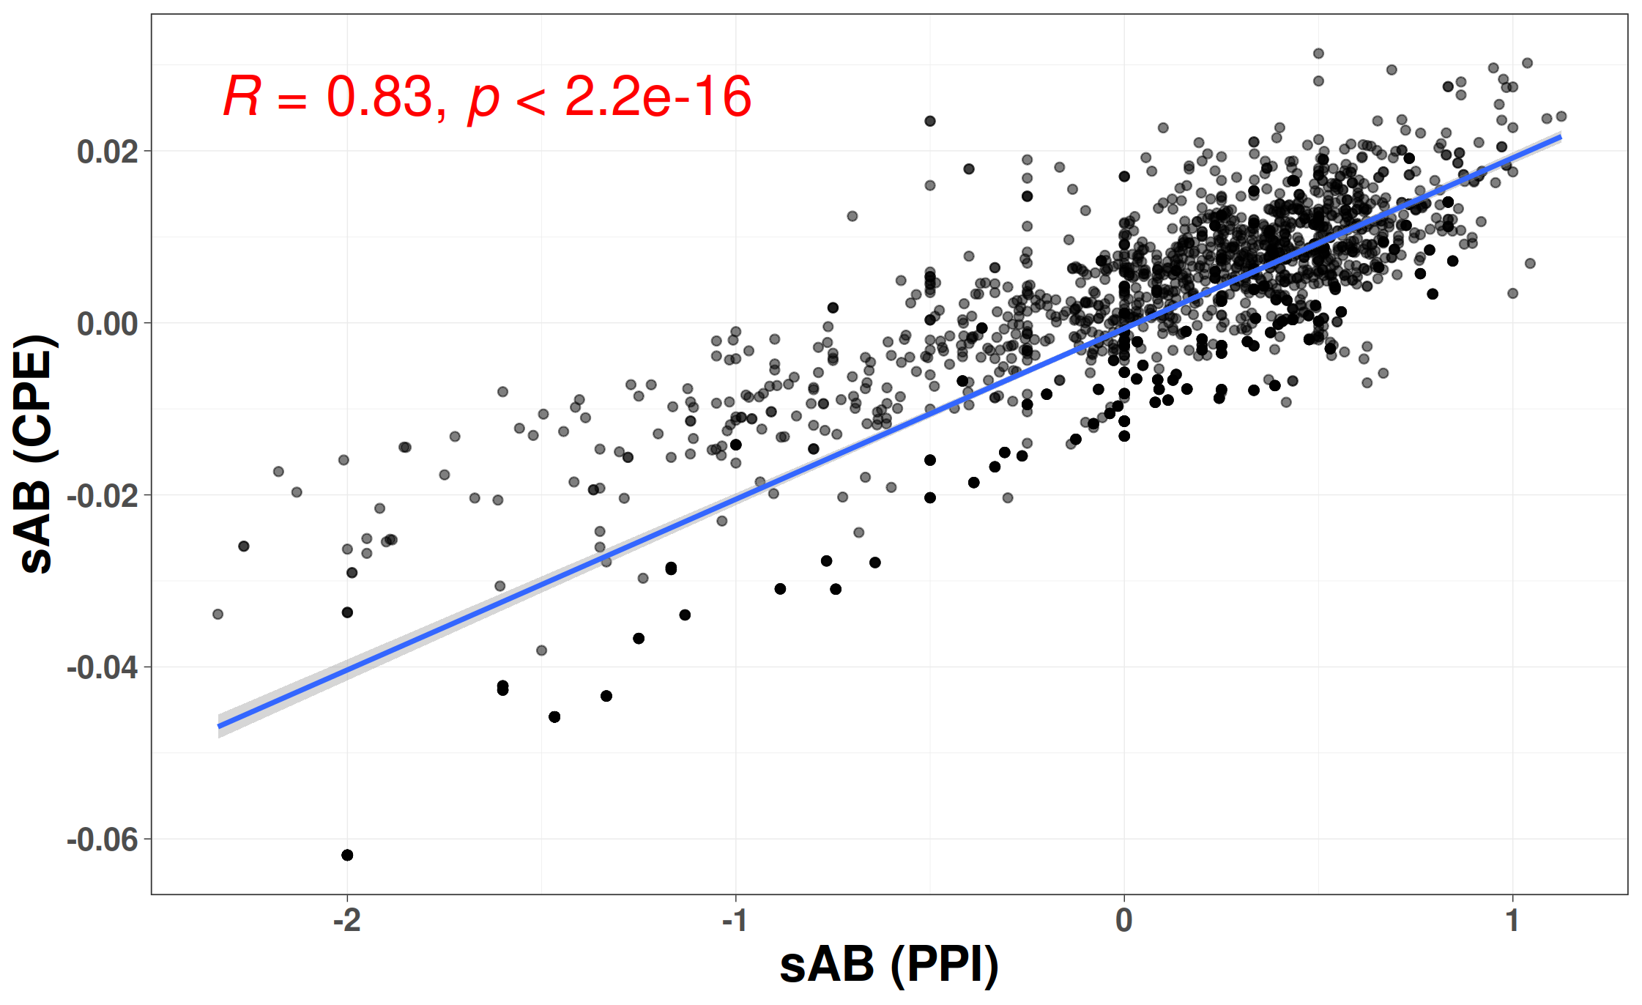

Figure 9. The correlation between separation distances estimated by protein-protein interaction network (X-axis) and the distance between profiles of energies (Y-axis).

**Analysis Tools and Packages**

All computational analyses were conducted using the versatile R programming language (www.r-project.org), with the utilization of various specialized packages tailored for specific tasks. Below is an overview of the packages and tools employed throughout our analysis:

The BIO3D package was used to read PDB files and analyze them. The Quickhull algorithm in the geometry package was used to find direct contacts and nearest neighbors of atoms using the Delaunay tessellation method. Class, random Forest, and e1071 packages were used for kNN, RF, and SVM classification methods, respectively, and cross-validation was performed using the caret package. To visualize the results, the ggplot2 package was used. The Ape and ggtree packages were used to implement and visualize hierarchical clustering and the NJ method.

**References**

1. Sayers, E.W., et al., *Database resources of the national center for biotechnology information.* Nucleic acids research, 2021. **49**(D1): p. D10.

2. Altschul, S.F., et al., *Basic local alignment search tool.* Journal of molecular biology, 1990. **215**(3): p. 403-410.

3. Lipman, D.J. and W.R. Pearson, *Rapid and sensitive protein similarity searches.* Science, 1985. **227**(4693): p. 1435-1441.

4. Mistry, J., et al., *Pfam: The protein families database in 2021.* Nucleic acids research, 2021. **49**(D1): p. D412-D419.

5. Jain, A., et al., *Analyzing effect of quadruple multiple sequence alignments on deep learning based protein inter-residue distance prediction.* Scientific Reports, 2021. **11**(1): p. 7574.

6. Szklarczyk, D., et al., *STRING v11: protein–protein association networks with increased coverage, supporting functional discovery in genome-wide experimental datasets.* Nucleic acids research, 2019. **47**(D1): p. D607-D613.

7. Pellegrini, M., et al., *Assigning protein functions by comparative genome analysis: protein phylogenetic profiles.* Proceedings of the National Academy of Sciences, 1999. **96**(8): p. 4285-4288.

8. Zhu, X., Y. Xiong, and D. Kihara, *Large-scale binding ligand prediction by improved patch-based method Patch-Surfer2. 0.* Bioinformatics, 2015. **31**(5): p. 707-713.

9. Sippl, M.J., *Boltzmann's principle, knowledge-based mean fields and protein folding. An approach to the computational determination of protein structures.* Journal of computer-aided molecular design, 1993. **7**: p. 473--501.

10. Mirzaie, M. and M. Sadeghi, *Knowledge-based potentials in protein fold recognition.* Archives of Advances in Biosciences, 2010. **1**(4).

11. Mirzaie, M. and M. Sadeghi, *Delaunay‐based nonlocal interactions are sufficient and accurate in protein fold recognition.* Proteins: Structure, Function, and Bioinformatics, 2014. **82**(3): p. 415-423.

12. Melo, F., R. Snchez, and A. Sali, *Statistical potentials for fold assessment.* Protein science, 2002. **11**(2): p. 430--448.

13. Dosztanyi, Z., et al., *The pairwise energy content estimated from amino acid composition discriminates between folded and intrinsically unstructured proteins.* Journal of molecular biology, 2005. **347**(4): p. 827--839.

14. Sillitoe, I., et al., *CATH: increased structural coverage of functional space.* Nucleic acids research, 2021. **49**(D1): p. D266-D273.

15. Lo Conte, L., et al., *SCOP: a structural classification of proteins database.* Nucleic acids research, 2000. **28**(1): p. 257-259.

16. Fox, N.K., S.E. Brenner, and J.-M. Chandonia, *SCOPe: Structural Classification of Proteins—extended, integrating SCOP and ASTRAL data and classification of new structures.* Nucleic acids research, 2014. **42**(D1): p. D304-D309.

17. Zhang, Y. and J. Skolnick, *Scoring function for automated assessment of protein structure template quality.* Proteins: Structure, Function, and Bioinformatics, 2004. **57**(4): p. 702--710.

18. Maiorov, V.N. and G.M. Crippen, *Significance of root-mean-square deviation in comparing three-dimensional structures of globular proteins.* Journal of molecular biology, 1994. **235**(2): p. 625--634.

19. Malod-Dognin, N. and N. Pržulj, *GR-Align: fast and flexible alignment of protein 3D structures using graphlet degree similarity.* Bioinformatics, 2014. **30**(9): p. 1259-1265.

20. Tian, K., et al., *Comparing protein structures and inferring functions with a novel three-dimensional Yau–Hausdorff method.* Journal of Biomolecular Structure and Dynamics, 2018.

21. Lundin, D., et al., *Use of structural phylogenetic networks for classification of the ferritin-like superfamily.* Journal of Biological Chemistry, 2012. **287**(24): p. 20565--20575.

22. Gowthaman, R., et al., *CoV3D: a database of high resolution coronavirus protein structures.* Nucleic acids research, 2021. **49**(D1): p. D282-D287.

23. van Heel, A.J., et al., *BAGEL3: automated identification of genes encoding bacteriocins and (non-)bactericidal posttranslationally modified peptides.* Nucleic Acids Research, 2013. **41**(W1): p. W448-W453.

24. Cheng, F., I.A. Kovács, and A.-L. Barabási, *Network-based prediction of drug combinations.* Nature communications, 2019. **10**(1): p. 1197.

25. Fox, N.K., S.E. Brenner, and J.-M. Chandonia, *SCOPe: Structural Classification of Proteins—extended, integrating SCOP and ASTRAL data and classification of new structures.* Nucleic acids research, 2014. **42**(D1): p. D304--D309.

26. Abrusán, G. and J.A. Marsh, *Alpha helices are more robust to mutations than beta strands.* PLoS computational biology, 2016. **12**(12): p. e1005242.

27. Wintjens, R.T., M.J. Rooman, and S.J. Wodak, *Automatic classification and analysis of αα-turn motifs in proteins.* Journal of molecular biology, 1996. **255**(1): p. 235-253.

28. Zhang, Y. and J. Skolnick, *TM-align: a protein structure alignment algorithm based on the TM-score.* Nucleic acids research, 2005. **33**(7): p. 2302-2309.

29. Malik, A.J., A.M. Poole, and J.R. Allison, *Structural phylogenetics with confidence.* Molecular Biology and Evolution, 2020. **37**(9): p. 2711--2726.

30. Gascuel, O., *BIONJ: an improved version of the NJ algorithm based on a simple model of sequence data.* Molecular biology and evolution, 1997. **14**(7): p. 685--695.

31. Andersson, C.S. and M. Högbom, *A Mycobacterium tuberculosis ligand-binding Mn/Fe protein reveals a new cofactor in a remodeled R2-protein scaffold.* Proceedings of the National Academy of Sciences, 2009. **106**(14): p. 5633-5638.

32. Högbom, M., *Metal use in ribonucleotide reductase R2, di-iron, di-manganese and heterodinuclear—an intricate bioinorganic workaround to use different metals for the same reaction.* Metallomics, 2011. **3**(2): p. 110-120.

33. Dyer, D.H., et al., *X‐ray structure of putative acyl‐ACP desaturase DesA2 from Mycobacterium tuberculosis H37Rv.* Protein science, 2005. **14**(6): p. 1508-1517.

34. Leahy, J.G., P.J. Batchelor, and S.M. Morcomb, *Evolution of the soluble diiron monooxygenases.* FEMS microbiology reviews, 2003. **27**(4): p. 449-479.

35. Merkx, M., et al., *Dioxygen activation and methane hydroxylation by soluble methane monooxygenase: a tale of two irons and three proteins.* Angewandte Chemie International Edition, 2001. **40**(15): p. 2782-2807.